PRESS RELEASE
Lagos, Nigeria
Peju Alatise, Sim and the Glass Birds, 2022, granite cast, stainless steel, and glass, four-sculpture installation.

Nigeria’s kó gallery presents Peju Alatise’s Sim and the Glass Birds at Frieze Sculpture 2022 in Regent’s Park, London.

kó is pleased to announce its participation in Frieze Sculpture, London, September 14-October 16, 2022, featuring Peju Alatise’s newest sculptural installation. Frieze Sculpture presents nineteen large-scale works by international artists in the English Gardens of Regent’s Park.

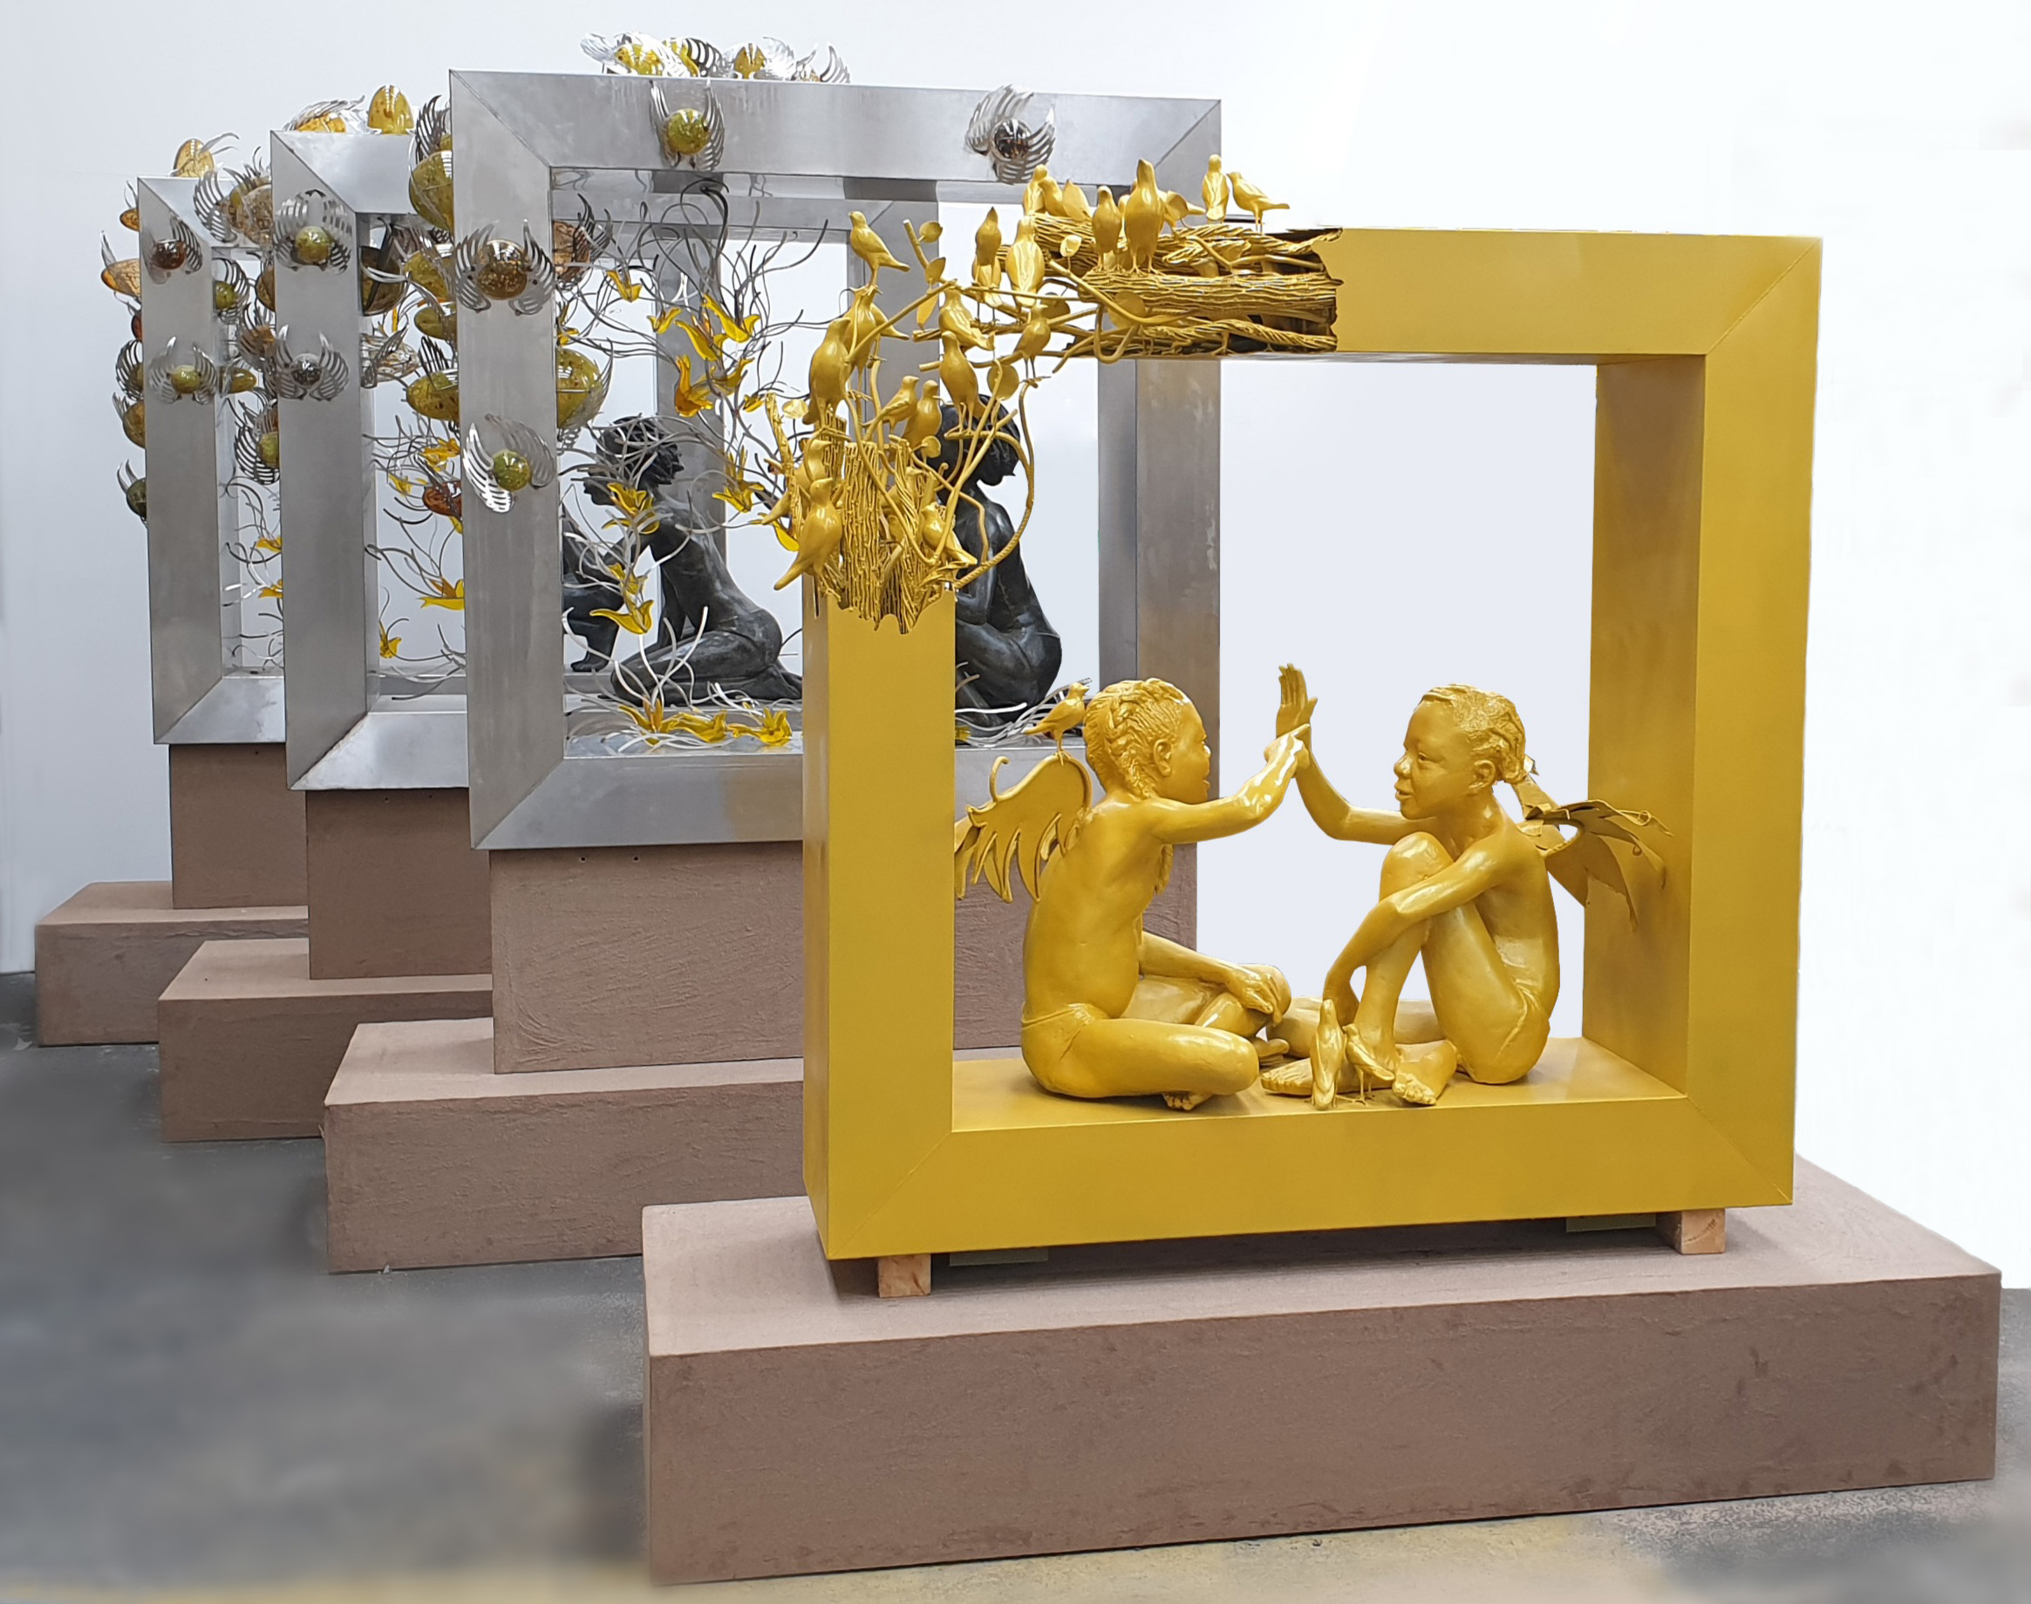
Peju Alatise is an interdisciplinary artist, architect, and author of two novels. A leading voice of contemporary art in Africa, Alatise produces artworks through the lens of spirituality and Yoruba cosmology, leaning into ancient storytelling traditions and crafting alternative social imagery. Her work is pointedly political, often provoking reflections about social issues both at home and abroad. Alatise has explored issues of exploitative labour practices in Nigeria, children’s rights with a focus on young girls, and state-sanctioned violence against citizens. Her artistic practice is relentlessly experimental and labour-intensive, working across a variety of mediums, techniques, and materials including painting, film, installation, and sculpture.

Sim and the Glass Birds (2022) is the latest installment of the artist’s career-long preoccupation with exploring the world of marginalised young girls through ambitious sculptural representation
and Yoruba mythology and folklore. Sim & The Glass Birds is the visual response to a story Alatise herself wrote about a young girl who constantly escapes to a dream world where she is safe and finds rest, away from the troubles of an earthly world that cages her ambitions,

relegates her to inferior citizenship, and declares she has no rights. Today, in Nigeria, a young girl under the age of twelve can be legally married. She can be “hired” and treated as an adult worker in domestic labour. She may not be allowed to seek an education. So little girls like Sim must find escape and release. Yoruba mythology is laden with stories of gods and creatures with powers commanding thunder, water, retribution, and abundance whose purpose for being is to protect and provide. It is in this dreamscape told through folklore and stories that Sim finds solace, and which Alatise employs as a point of departure for her sculptures.

In this four-panel installation, incorporating granite cast, stainless steel, and glass, the character Sim is suspended in this dreamscape, crossing a portal between Earthly life and the other world. She is in the company of foreboding and mythological creatures — glass birds in flight — which are caught over the panels and which will eventually break. Its delicate nature is a metaphor for the fleeting nature of escape in itself and its inevitable, unfortunate end.

Peju Alatise (b. 1975, Nigeria) exhibited at the Venice Architectural Biennale in 2021 and was selected to represent Nigeria’s debut pavilion at the Venice Art Biennale in 2017. She was the recipient of the FNB Art Prize at the Joburg Art Fair in 2018. Alatise is a fellow at the National Museum of African Art, part of the Smithsonian Institution, and work has been collected by the Smithsonian Institute. She is the founder of Alter Native Artists Initiative, an incubatory artist collective that offers training programs and residencies to young, emerging artists. Her debut novel, Orita Meta, chronicling the interwoven path of three women, was nominated for the ANA/Flora Nwapa Prize for Women’s Writing in 2006. Alatise is based in Lagos, Nigeria and Glasgow, UK.

ABOUT kó
kó is an art gallery based in Lagos, Nigeria, that is dedicated to promoting modern and contemporary art. kó has a dual focus in championing Nigeria’s leading artists from the modern period and celebrating emerging and established contemporary artists across Africa and the Diaspora. In addition to its annual exhibition program in Lagos, kó participates regularly in international art fairs. In 2020, kó participated in Frieze Masters London presenting the work of
pioneering Nigerian modernist Ben Enwonwu. In 2021, kó presented Nigerian artist Obiora Udechukwu at Frieze Masters London, where four artworks were acquired by the Tate, and Untitled Art Fair in Miami. In 2022, kó participated at 1:54 Paris and will exhibit at The Armory Show, New York; Frieze Masters London featuring pioneering Nigerian artist Nike Davies-Okundaye; Abu Dhabi Art; and Art X Lagos. kó has also showcased the work of several emerging African and Diasporan artists, many of whom participated in artist residencies with the gallery in Lagos.

